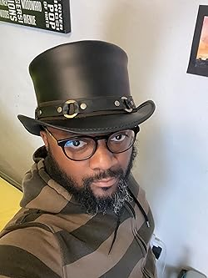

**Work**

Attendance

Safety

Education

**Business**

Promotions

Compensation

Come Out or Stay In

We will Live Stream from Our Headquarters in Toledo, Ohio

The No-tie Night We Celebrate Outstanding Achievements in Business and Work Across Five Categories:

Annual

Hats Off Awards